Development of POS & Inventory Management System

Imtiaz Ahmed Afzal
ID # 16103283

A practicum report submitted in partial fulfillment of the requirements for the award of Bachelor of Computer Science and Engineering



Department of Computer Science and Engineering
College of Engineering and Technology
IUBAT– International University of Business Agriculture and Technology

Fall 2020
Development of POS & Inventory Management System

Imtiaz Ahmed Afzal

A practicum report submitted in partial fulfillment of the requirements for the degree of Bachelor of Computer Science and Engineering (BCSE)

The practicum has been examined and approved,

Prof Dr. Utpal Kanti Das
Coordinator and Professor
Dept. of Computer Science and Engineering
IUBAT – International University of Business
Agriculture and Technology

Md. Alomgir Hossain
Assistant Professor

Dept. of Computer Science and Engineering
IUBAT – International University of Business Agriculture and Technology

Letter of Transmittal

14th January, 2021
Coordinator,
Practicum and Placement Board,
College of Engineering and Technology - CEAT
IUBAT — International University of Business Agriculture and Technology
4 Embankment Drive Road, Sector – 10, Uttara Model Town,
Dhaka-1230, Bangladesh
Subject: Letter of Transmittal.

Sir,
With due respect, I want to acquaint you that, it is a great experience as well as immense pleasure for me to submit this report titled “POS & Inventory” for the fulfillment of my Practicum course.
It was a splendid opportunity for me to work on this project to actualize my theoretical knowledge and has an enormous exposure with the corporate culture of a renowned company. Now I am looking forward for your kind appraisal regarding this practicum report.
I shall remain deeply grateful to you if you kindly go through this report and evaluate my performance.

Thanking you

Imtiaz Ahmed Afzal
ID# 16103283

Letter of Authorization

14th January, 2021
IUBAT – International University of Business Agriculture and Technology
4 Embankment Drive Road, Sector -10
Uttara Model Town, Dhaka-1230

Subject: Letter of Authorization
Dear Imtiaz Ahmed Afzal
You will be happy to know that project on “POS & Inventory” has been accepted by the department. We hope you will successfully complete the project on time. After successful completion of the project, you are requested to write a report based on the project.

For any kind of needs don’t hesitate to contact with us.

Co Supervisor  Prof Dr. Utpal Kanti Das  _________________________  Coordinator  Department of Computer Science  and Engineering | Supervisor  Md. Alomgir Hossain  _______________________  Assistant Professor  Department of Computer Science  and Engineering

Student’s Declaration

I am Imtiaz Ahmed Afzal, student of BCSE-Bachelor of Computer Science and Engineering program, under the College of Engineering and Technology (CEAT) of International University of Business Agriculture and Technology (IUBAT) declaring that, this report on the topic of “POS & Inventory” has been prepared for the fulfillment of the internship course CSC 490, which is the partial requirement of Bachelor of Computer Science and Engineering degree.

The report and the project on ‘POS & Inventory’ are originally prepared by me. All module and procedure of this project made after proper inspection and internet information.

It has not been prepared for any other purposes, rewards or presentations.

Imtiaz Ahmed Afzal
ID #16103283
Program: BCSE

Acknowledgements

In the name of Allah, most merciful, most gracious and most benevolent.
I am very much grateful to thank a few people who have, assisted, encouraged, directed and supported me throughout my practicum program.
I want to thank my parents, who have endowed their immeasurable-innumerable support and encouragement to attain this exquisite event of my life.
I am very appreciative for Late Md. Alimullah Miyan (Founder of IUBAT) for his unrelenting direction and sustain throughout his life for the betterment of education system in Bangladesh. Almighty rest his soul in peace.
I would like to mention Late Prof Dr. Md Abdul Haque (was Chairperson and Professor) of the CSE department whose dedication for the betterment of our department and IUBAT can never be forgotten.
My sincere thanks to our Vice Chancellor Dr. Abdur Rab Sir, who is maintaining every department with his own concern and gave me an opportunity to submit this report as part of my engineering degree completion.
My outmost and sincere gratitude goes to Prof. Dr. Utpal Kanti Das, Coordinator of Department of Computer Science and Engineering, who is most sincere and responsible person for the design of our course curriculum, for which we experience the professional environment and working experience on real life projects.
I would like to pay my gratitude to my honorable advisor Md Alomgir Hossain, Assistant professor of Computer Science & Engineering Department, who has guided me all through my project and report, for not only in this semester but also throughout my university life by giving his valuable suggestions and advices at any time, any situation. I was able to develop this project and report effectively and properly only for his perfect guidance.
Last but not least, I sincerely would like to thank The Genius Ocean for giving me the opportunity to complete my internship and project at.
Their continuous encouragement and contribution gave me the courage and determination needed to complete the internship and project properly

Supervisor’s Certification

This is to certify that Practicum report on “POS & Inventory” has been carried out by Imtiaz Ahmed Afzal bearing ID# 16103283, of IUBAT – International University of Business Agriculture and Technology as a partial fulfillment of the requirement of practicum defense course. The report has been prepared under my guidance and is a record of the accomplished work, carried out successfully. To the best of my knowledge and as per his declaration, no parts of this report has been submitted anywhere for any degree, diploma or certification.

Now he is permitted to submit the report. I wish him success in all his future endeavors.

Practicum Supervisor

_______________________
Md Alomgir Hossain
Assistant Professor,
Department of Computer Science and Engineering
IUBAT- International University of Business Agriculture and Technology
.

Department Certification

On behalf of the Department of Computer Science and Engineering of IUBAT- International University of Business Agriculture and Technology, we, the undersigned, certify that this practicum report “POS & Inventory” for the award of Bachelor of Computer Science and Engineering (BCSE) degree was duly presented by Imtiaz Ahmed Afzal (ID No.16103283) and accepted by the department.

___________________________
Md. Alomgir Hossain
Supervisor,
Assistant Professor, Department of Computer Science and Engineering
IUBAT- International University of Business Agriculture and Technology

___________________________
Prof. Dr. Utpal Kanti Das
Professor & Coordinator
Department of Computer Science and Engineering
IUBAT- International University of Business Agriculture and Technology

Abstract

This report is for practicum defense. The primary objective of this report is to learn how to conduct a project and work in real field and write it down in a formal and specific way. The secondary objective of this report is to learn about how this Point of Sale System can manage ordering process for customer more effective. The Point of Sale System is developed for providing the ordering and manage service to the staff of the Shop without facing any problem. Currently the shop handles all process manually which a very time is consuming and complex. This software not only deals with ordering products but also deals with the internal operation of the shop also. There are two types of user in this system including Admin and Staff. Admin can handle user access to the system by giving their permission to a specific module and see the sales report. Also, admin can manage expense, purchase, products, categories and set settings to run the system smoothly. Admin also able to see various reports. Staff able to create new order suspend a sale, print invoice for the sale and add payment to a sale. This system reduces time consumption to perform a task like get report or calculate total of an order. The main objective of this system is to automate the ordering process and calculate total and generate report. I have plans to implement other features in future. I could not add all of them just because of the time limitation. At the end of the day, what I can say is I put my honest effort and hard work to implement the system as efficient as possible. I wish to make it flawless in near future

Table of Contents

Letter of Transmittal…………………………………………………………………….... | iii
Letter of Authorization……………………………………………………………………. | iv
Students Declaration………………………………………………………………………. | v
Acknowledgement……………………………………………………………………….… | vi
Supervisor’s Certification………………………………………………………………… | vii
Departments Certification………………………………………………………………… | viii
Abstract…………………………………………………………………………………….. | ix
List of Figures……………………………………………………………………………… | xiv
List of Tables………………………………………………………………………………. | xv

Chapter 1: Organizational Overview 1
  - Organization Overview 2
  - Vision & Mission 2
  - My Position in this Company 3
  - Organization Services 3
  - Organization Technologies 3
  - Organizational Structure 4
Chapter 2: Project Overview 5
  - Chapter Overview 6
  - Project Overview 6
  - Objectives 6
    - Board Objective 7
    - Specific Objectives 7
  - Scope of the Project 7
  - Limitations of the Project 7
  - System Benefits 8
  - Methodologies 9
  - Data Sources 9
  - Selection of project development process model 9
  - Reason why I choose the Waterfall process model 10
  - Feasibility Study 10
    - Technical feasibility 11
    - Economic Feasibility 11
    - Operational feasibility 11
Chapter 3: Requirement Engineering 12
  - Requirements Engineering 13
    - User Requirements 13
    - System Requirements 14
    - Functional Requirements 19
    - Non- Functional Requirements 20
  - Use Case Diagram 20
  - Use Case Description 22
Chapter 4: Analysis Modeling 24
  - Class-responsibility-collaboration Card 25
  - Activity Diagram 31
    - Activity Diagram for Owner 32
    - Activity Diagram for Staff 33
  - Swim lane Diagram 34
    - Swim Lane Diagram for Owner 35
    - Swim Lane Diagram for Staff 36
Chapter 5: Risk Management 37
  - Risk Management 38
  - Risk Identification 38
  - Risk Analysis 39
  - Risk Planning 40
  - Risk Monitoring 40
Chapter 6: Project planning and scheduling 41
  - Functions of Proposed System 42
  - Function Specification 42
  - Function Point Estimation 44
  - Process Based Estimation 48
  - Effort Distribution 50
  - Project Schedule 51
Chapter 7: Project Estimation 52
  - Project Estimation 53
  - Personal cost 53
  - Hardware cost 54
  - Software cost 54
  - Other Cost 54
  - Accounts table 55
Chapter 8: Quality Management 56
  - System Quality Management 57
  - Software Quality Management Processes 57
  - Quality Planning 57
  - Quality Assurance 57
  - Quality Control 57
Chapter 9: Designing 58
  - Data Flow Diagram 59
    - Context Level DFD 59
    - Level 1 DFD 60
    - Level 2 Process 1 61
    - Level 2 Process 2 61
    - Level 2 Process 3 62
    - Level 2 Process 4 62
    - Level 2 Process 5 63
    - Level 2 Process 6 63
    - Level 2 Process 7 64
    - Level 2 Process 8 64
    - Level 2 Process 9 65
    - Level 2 Process 10 65
    - Level 2 Process 11 66
  - Database Design 66
    - Entity Relationship Diagram 66
    - Normalization 68
    - Database Field Design 70
Chapter 10: Testing 73
  - Software Testing Strategy 74
  - System Testing Methodology 75
    - Black-box Testing 75
    - White-box Testing 75
  - Testing 76
Chapter 11: Conclusion 80
  - Practicum and Its Value 81
  - Future Plan 81
  - Conclusion 81
Appendix 82
References 85
Books: 85
Websites: 85
Work Cited: 85

List of figures
Figure 1: Organizational Structure Genius Ocean. 4
Figure 2: WaterFall Process Model 10
Figure 3: Use case diagram 21
Figure 4: Activity Diagram for Admin 32
Figure 5: Activity Diagram for Staff 33
Figure 6: Swim Lane Diagram for Admin 35
Figure 7: Swim Lane Diagram for Staff 36
Figure 8: Effort Based Estimation 50
Figure 9: Project Scheduling Chart 51
Figure 10: Context level Data Flow Diagram 59
Figure 11: Level 1 data flow diagram 60
Figure 12: Level 2 Process 1 61
Figure 13: Level 2 Process 2 61
Figure 14: Level 2 Process 3 62
Figure 15: Level 2 Process 4 62
Figure 16: Level 2 Process 5 63
Figure 17: Level 2 Process 6 63
Figure 18: Level 2 Process 7 64
Figure 19: Level 2 Process 8 64
Figure 20: Level 2 Process 9 65
Figure 21: Level 2 Process 10 65
Figure 22: Level 2 Process 11 66
Figure 22: Level 2 Process 12 66
Figure 22: Level 2 Process 13 66
Figure 22: Level 2 Process 14 66
Figure 23: Entity Relationship Diagram for Point of Sale 67

List of Tables
Table I: Technical Feasibility Study 11
Table II: Risk Identification 38
Table III: Risk Analysis 39
Table IV: Risk Planning 40
Table V: Function Specification 43
Table VI: Transaction function 44
Table VII: Data Functions 45
Table VIII: Unadjusted Function Point Contribution (Transition Function) 46
Table IX: Unadjusted Function Point Contribution (Data Function) 46
Table X: Performance and Environment Impact 46
Table XI: Function Point Estimation 48
Table XII: Process Based Estimation 49
Table XIII: Salary range 53
Table XIV: Hardware Cost 54
Table XV: Software cost 54
Table XVI: Other Cost 54
Table XVII: Accounts Table 55
Table XVIII: Database Field Design 70
Table XIX: Daily sale information module testing 76
Table XX: POS terminal testing 76
Table XXI: Manage expenses module testing 76
Table XXII: Manage products module testing 76
Table XXIII: Manage category list module testing 77
Table XXIV: Manage Purchases module testing 77
Table XXV: Sale report manage module testing 77
Table XXVI: Manage Customers module testing 77
Table XXVII: Manage Users module testing 78
Table XXVIII: Manage Due module testing 78
Table XXIX: Manage notification module testing 78
Table XXX: Manage theme module testing 78
Table XXXI: Manage setting module testing 79
Table XXXII: Manage invoice module testing 79
Table XXXIII: Report module testing 79

Chapter 1: Organizational Overview

Organization Overview

Genius Ocean is a one-stop web & software solutions provider company, where we provide software services. It’s initially started out its business in February 2017. It has been involved in the development of outsourcing from the very beginning and therefore all services highlight the experience of development. It is a consultancy company where knowledge, process and proven methodologies converge to deliver compelling, high value and cost-effective services in record time. The company offers software development and maintenance services all over the world, currently we are working with USA, Malaysian, Singapore, Australian, and UK based client. We have developed a unique collaborative model of partnering with clients to deliver great software products to market rapidly and economically. We were working on Web development, App development (iOS, Android) and Digital Marketing. We are also working on a cloud-based solution, UI & UX Design, E-commerce services. Our goal is to become the most respected, trusted, and preferred software consulting firm in the industry by providing only the highest quality services to our clients at an affordable price. We're dreaming bigger than ever now in 2025.A dedicated support team is assisting users and caring for their problems. We also carry out community works to develop market talents and participate whenever possible in various international events.

Vision & Mission

Each project can have unique requirements, and we fully appreciate that. Rather than rigidly imposing a one-size-fits-all approach, we meticulously analyze your business needs and suggest the optimal way to make your project succeed. Since 2017, we have accumulated a wealth of expertise in many popular development methodologies, with Scrum being our weapon of choice. We also keep a close eye on, and adopt best practices from other agile methods, such as Lean and Scrum ban.
Upon the delivery of the project, you receive:

- Software Product
- Installation and maintenance
- Documentation (Requirement & Design)
- Setup program
- User manual
- Warranty

My Position in this Company

I am working as a Php Developer in this company.

Organization Services

Following services are provided by Genius Ocean:
    - Application Development
    - Product Development & Maintenance
    - Enterprise Solutions
    - Mobile Apps
    - Testing & QA
    - UI / UX Design
    - Dedicated Development Center
    - Ecommerce

Organization Technologies

Following technologies are user by Genius Ocean:
    - Salesforce
    - PHP
    - iOS
    - Android
    - Python
    - Other Technologies
    - Announcement

Organization Structure

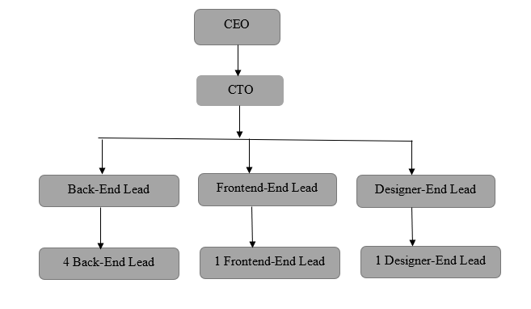

Figure 1: Organizational Structure Genius Ocean.

Chapter 2: Project Overview

Chapter Overview

Internship is a practical experience of theoretically gained knowledge and can measure as a groundwork trial to be aware with any organization and to make oneself confident enough to enter service life and start building career. And, wonderful and effective way to connect academic experience with the professional work arena. It allows gaining valuable experience to the workplace, provides the opportunity for skill development, and gives a competitive edge in the job search. This chapter attempts to describe the objectives, scope and all topics of initialization period of this project.

Project Overview

Point of Sale is a Web based application. Point of Sale software is a system, that handle the regular activity of a café. Using point of sale software user can perform selling and manage product, manage expense, purchases, staff and permission of users. Point of Sale software not only deals with sales but also deals with order process. The software stores all sales date to date record with quantity, cost, selling price, discount and other information’s. In this Point of Sale software, the system auto calculates total price, discount and other charges of a product and order. The software also keeps records of orders, bills and payment receipts of an order. Software able to suspend/hold a sale while need to add another order. Using the software user can process payment using only hand cash now. Hopefully, bKash and DBBL services will be added afterwards. The store can manage their expenses through the system. It is also possible to generate sales report, loss/profit report and many more. Some reports are visualized by the chart. Owner and Staff login system are separated to make the system more secure with proper permission.

Objectives

The objective of this system is to make sales system easy, reliable, user friendly, and corrective. Moreover, less time consuming as compared to manual work. The main objective of this system is to automate the system of the store, store information electrically and generate report to take proper decision.

Board Objective
To develop a time efficient and reliable purchase platform for products by applying the educational knowledge and experience gathered from International University of Business Agriculture and Technology (IUBAT).

Specific Objectives
      - To develop user friendly application
      - To develop a system which helps to find and order product easily
      - To develop a system to secure payment transaction
      - To develop an admin panel to manage all the business activity digitally
      - To develop a system to automate the calculation of an order
      - To develop a system to track down sales.

Scope of the Project

The aim of this project is to automate the ordering system of shop. Admin will add staff to perform their task. Admin can manage products, sales, expenses, and purchases. Staffs can create a new order and print receipt for the order and edit or add payment to an order. Admin and staff can generate various report to track down profit/loss and sales performance of the shop. All the processes will be done in the following proper software development process.

Limitations of the Project

This project is the real-life implementation of the knowledge regarding software development gathered throughout the graduation program. But it was difficult for me to implement all the terms and condition of software development process as a fresh graduate. Initially it was really a big issue but, gradually with the supports of some senior experts and honorable supervisor, I adapt myself with the environment.

System Benefits

The system benefit of this project has been described below

Easy Access into the Software
The Binod Daily Shop is a shop with modern outlook and technological system. Shop Staffs spend busy time to maintain their quality and serve customer. They need faster and accurate process to maintain their daily job. This system made their work more easy and faster than manual system and all data will be accurate.

Faster Transaction
The staff spend their time to sale the items and they need an automatic system to handle payment transaction and calculate prices and total. While many customers recommend cash payment, it is only possible to handle online payment using an automated system only. Invoice receipt are made faster than previous using the automated system.

Accurate Record keeping
The data that sales staff save into the system will be accurate by the system. Numeric and text data will check by system and important input fields can’t be empty.

To automate the whole sales process.
In sales system staff need to just select the item name, information that related to the item will auto come up and staff will just provide the quantity of item (discount and other facts too) and system will print the invoice.

Get all reports by date to date easily.
Using the system owner can easily generate and check the sales statement, expense statement and loss/profit. Top item list, previous sales records etc.

Methodologies

The procedures and processes that I followed to develop this system are clearly described in the “Analysis & Design” chapter with illustrations. The methodologies are derived from the collected data of the early requirement gathering phase.

Data Sources

The sources of data for the purpose of this project are:
- Primary
- Secondary
The primary data are collected based on user requirements of the software, suggestions of intern organization and the practical experience of senior experts.
The Secondary data are gathered by studying different books, newspaper, journals and information collected via internet. I studied many other open sources management projects documentations and data on the internet to understand the project better.

Selection of project development process model

Waterfall model is the earliest SDLC approach that was used for software development. The waterfall Model illustrates the software development process in a linear sequential flow; hence it is also referred to as a linear-sequential life cycle model. This means that any phase in the development process begins only if the previous phase is complete. In waterfall model phases do not overlap
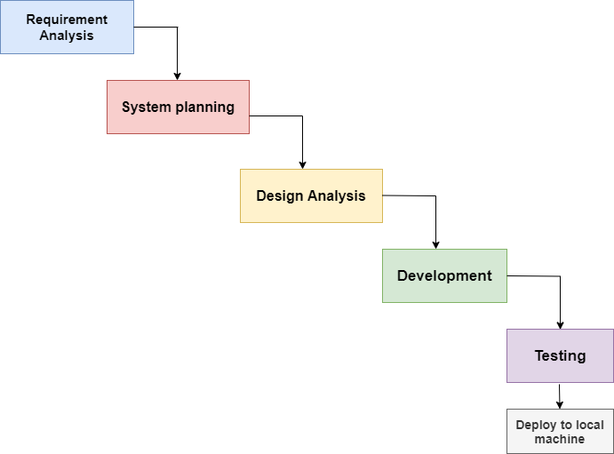
Figure 2: Waterfall Process Model.

Reason why I choose the Incremental process model

- This model is simple and easy to understand and use.
- Its process activities are clearly separated and organized.
- Waterfall model works well of smaller projects where requirements are very well understood.
- All the requirements for this project are already known.
- Technology is understood.

Feasibility Study

Feasibility study determines whether that solution is feasible or achievable for the organization. There are three major areas of feasibility study.
- Technical feasibility
- Economic feasibility
- Operational feasibility

Technical feasibility
The technical feasibility assessment is focused on gaining an understanding of the present technical resources of the organization and their applicability to the expected needs of the proposed system. It is an evaluation of the hardware and software and how it meets the need of the proposed system
Table I Software and Hardware Requirements
Hardware Requirement | Software Requirement
Computer (Desktop/Laptop/Equivalent) | Operating System (Windows 7/10 or equivalent) with VS Code (IDE)
Proper electricity Support | PHP(Laravel)
Adequate system memory and secondary  Memory | MySQL

Economic Feasibility
Generally, it means whether a business or a project feasible cost wise and logistically. We consider whether the company will be able to pay cost for redesigning and whether the project will be cost effective or not.

Operational feasibility
Operational feasibility addresses concern about user acceptance, management support, and the requirements of entities and factors in the organization’s external environment. The proposed system is designed from a client’s point of view. So, all the features are included only to benefit the users.

Chapter 3: Requirement Engineering

Requirement analysis provides the software designer with a representation of information, function and behavior that can be translated to data, architectural, interface and component level designs. In the following task phases the requirement analysis was done.

Requirements Engineering

Requirement analysis, also called requirements engineering is an important aspect of project management. The process of finding out, analyzing, documenting and checking these services and constrains is called requirements engineering. Requirements engineering as its name suggests, the engineering discipline of establishing user requirements and specifying software systems. There are many definitions of Requirements Engineering; however, they all share the idea that requirements involve finding out what people want from a computer system and understanding what their needs mean in terms of design. Requirements engineering is closely related to software engineering, which focuses more on the process of designing the system that users want.
    - User Requirement
    - System Requirement
    - Functional Requirement
    - Non-Functional Requirement

3.1.1 User Requirements
A. Admin can view various report
B. Admin can view today’s sales details
C. Admin can manage sale (edit, delete or void a sale)
D. Admin can view all category and add, edit and delete category
E. Admin can view product list and add, edit, and delete products
F. Admin can view expense and add, edit, search and delete Expense
G. Admin can view, add, edit and delete supplier
H. Admin can view, add, edit and delete customer
I. Staff can manage sale (edit, delete or void a sale)
J. Admin and Staff can view all sales details
K. can view product list and add, edit, and delete products
3.1.2 System Requirements
A. Admin can view various report
a. Admin click on the Report/ profit/loss reports from the top bar dropdown.
b. Admin can view profit/loss report
B. Admin can view today’s sales details
a. Admin click on Sales List (POS) / Sale Today from top bar.
b. Admin can search order from search order.
C. Admin can manage sale (edit, delete or void a sale)
a. By clicking the POS button from left bar menu owner navigate to pos main screen
b. It will appear point of sale page.
c. From the right side all product will appear category wise.
d. From right side select item (product), then it will appear into the cart with its price and other details.
e. Set quantity from cell or quantity can be increased/decreased by clicking on the same product from the right side again and again.
f. Admin can view total quantity, sub total, vat, total from the cart.
g. Admin can add customer top bar add customer.
h. To Make sale add customer, pay amount, due amount and pay by.
i. Invoice can be print by clicking on print button.
D. Admin can view all category and add, edit and delete category
a. By clicking on product/category button from left bar, Admin can navigate to category list.
b. Category list will show all the information about each category in a table.
c. By clicking on Add Category button at the top the category table, it will appear modal.
d. By filling necessary information, a new category can be added.
e. By clicking edit icon, a popup will appear, and admin can edit and update existing category.
f. By clicking on delete icon owner can delete specific category.

E. Admin can view product list and add, edit, and delete products
a. By clicking on product/product list button from left bar, owner can navigate to product list.
b. Product list will show all the information about each product in a table.
c. By clicking on Add Product button at the top the product table, admin will navigate to new component.
e. By filling necessary information, a new product can be added with image(optional) and admin will be redirected to product list component.
f. By clicking edit icon, a popup will appear, and owner can edit and update existing product.
g. By clicking on delete icon owner can delete specific product.

F. Admin can view expense and add, edit, search and delete Expense
a. By clicking on expense button from left bar, owner can navigate to expense list.
b. Expense list will show all the information about each expense in a table.
c. By clicking on Add Expense button at the top the expense table, it will appear modal.
e. By filling necessary information, a new expense can be added, and admin will be redirected to expense list component.
f. By clicking edit icon, a popup will appear, and owner can edit and update existing expense.
g. By clicking on delete icon owner can delete specific expense.

G. Admin can view, add, edit and delete supplier
a. By clicking on supplier button from left bar, owner can navigate to vendor list.
b. Supplier list will show all the information about each supplier in a table.
c. By clicking on Add Supplier button at the top the vendor table, it will appear modal.
d. By filling necessary information, a new supplier can be added, and admin will be redirected to supplier list page.
f. By clicking edit icon, a popup will appear, and owner can edit and update existing supplier.
g. By clicking on delete icon owner can delete specific supplier.

H. Admin can view, add, edit and delete customer
a. By clicking on customer button from left bar, owner can navigate to customer list.
b. Customer list will show all the information about each customer in a table.
c. By clicking on Add Customer button at the top the customer table, it will appear modal.
e. By filling necessary information, a new customer can be added, and admin will be redirected to customer list component.
f. By clicking edit icon, a popup will appear, and admin can edit and update existing customer.
g. By clicking on delete icon admin can delete specific customer.

I. Staff can manage sale (edit, delete or void a sale)
a. By clicking the POS button from left bar menu owner navigate to pos main screen
b. It will appear point of sale page.
c. From the right side all product will appear category wise.
d. From right side select item (product), then it will appear into the cart with its price and other details.
e. Set quantity from cell or quantity can be increased/decreased by clicking on the same product from the right side again and again.
f. Staff can view total quantity, sub total, vat, total from the cart.
g. Staff can add customer top bar add customer.
h. To Make sale add customer, pay amount, due amount and pay by.
i. Invoice can be print by clicking on print button.

J. Admin and Staff can view all sales details
a. Staff click on Sales List (POS) / Sale Today from top bar.
b. Staff can search order from search order.
K. Staff can view product list and add, edit, and delete products
a. By clicking on product/product list button from left bar, owner can navigate to product list.
b. Product list will show all the information about each product in a table.
c. By clicking on Add Product button at the top the product table, staff will navigate to new component.
e. By filling necessary information, a new product can be added with image(optional) and staff will be redirected to product list component.
f. By clicking edit icon, a popup will appear, and staff can edit and update existing product.
g. By clicking on delete icon owner can delete specific product.

3.1.3 Functional Requirements
a. All products should show first as default.
b. 3 row 4 column products should be shown.
c. Image should not more than 1 MB

3.1.4 Non- Functional Requirements
a. Easy user interface
b. Responsive design
c. No internet connection needed
d. High security

3.2 Use Case Diagram
A use case diagram is a graphic depiction of the interactions among the elements of a system. A use case is a methodology used in system analysis to identify, clarify, and organize system requirements

Actor: An actor is a user of the system playing a particular role.
Use case: Use case is a particular activity a user can do on the system.

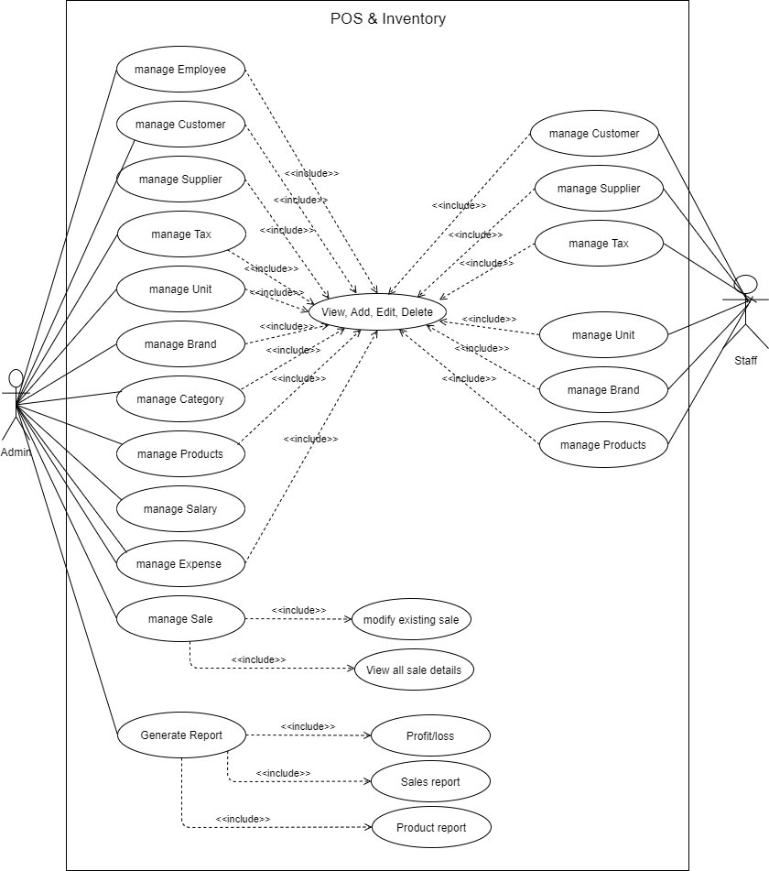

Use Case Description

Use Case: Manage User
Actor: Admin
Description: Admin will create and modify user for the system.
Use Case: Manage User Permission
Actor: Admin and Staff
Description: User will setup theme and other setting with given permission.
Use case Title: View Details
Actor: Admin
Description: Admin will be able to see daily sales information with revenue chart and top selling items.

Use case Title: Generate Report
Actor: Admin
Description: Admin can see sales, product, profit and daily sales report.

Use case Title: Manage Expenses
Actor: Admin
Description: Admin can view and modify expenses.

Use case Title: Settings
Actor: Admin
Description: Admin can manage and shop setting and theme.

Use case Title: Manage Category
Actor: Admin
Description: Admin can view and modify categories.

Use case Title: Manage Product
Actor: Admin
Description: Admin can view and modify products.

Use case Title: Manage Purchases
Actor: Admin
Description: Admin can view and modify purchases.
Use case Title: Manage Sale
Actor: Staff and Admin
Description: Staff and Admin can see/modify sales, see selected customer details and add payment to selected payment.

Use case Title: Make sales and invoice
Actor: Admin and Staff
Description: Admin and Staff can add/ search/ modify products, suspend sale, add payment and print bill.

Chapter 4: Analysis Modeling

Class-responsibility-collaboration Card

Class-responsibility-collaboration (CRC) cards are a brainstorming tool used in the design of object-oriented software. They were originally proposed by Ward Cunningham and Kent Beck as a teaching tool but are also popular among expert designers and recommended by extreme programming supporters. Martin Fowler has described CRC cards as a viable alternative to UML sequence diagram to design the dynamics of object interaction and collaboration.
CRC cards are usually created from index cards. Members of a brainstorming session will write up one CRC card for each relevant class/object of their design.
The card is partitioned into three areas:

- On top of the card, the class name
- On the left, the responsibilities of the class
- On the right, collaborators (other classes) with which this class interacts to fulfil its responsibilities

Class name: Admin
Class type: Role
Class characteristics: Tangible; Sequential; Persistent; Guarded
Responsibilities: Log in & Log out Manage users Manage products Manage Unit  Manage tax  Manage brands  Manage categories Manage expenses Manage customers Manage suppliers Manage Sales Manage due  Set Payment See all reports | Collaborators: User Products Sales  Unit Categories Customers  Supplier  Payments

Class name: Staff
Class type: Role
Class characteristics: Tangible; Sequential; Persistent; Guarded
Responsibilities: Log in & Log out See products  See categories See customers See previous sales | Collaborators: Sales Products Customers

Class name: Products
Class type: Things
Class characteristics: Abstract; Sequential; Persistent; Guarded
Responsibilities: Add products Delete products Edit products  Get categories id and name Generate barcode | Collaborators: Sales Categories

Class name: Expenses
Class type: Things
Class characteristics: abstract; Sequential; persistent; guarded
Responsibilities: Get date Knows amount Category id Knows note Added by | Collaborators: Owner Staff

 | Class name: Sales
 | Class type: Events
 | Class characteristics: Abstract; Sequential; Persistent; Guarded
 | Responsibilities: Add customer Add sales note Add products Set discount Sub all discount Calculate total |  | Collaborators: Customers Products
Class name: Sale items
Class type: Things
Class characteristics: Tangible; Sequential; Persistent; Guarded
Responsibilities:  Get sale id Knows product id  Knows product name Knows product cost Get quantity  Get cost total  Sub discount amount Calculate total |  | Collaborators: Products Sales

 | Class name: Vendor
 | Class type: Properties
 | Class characteristics: Abstract; Sequential; Persistent; Guarded
 | Responsibilities: Add vendors Delete vendors Edit vendors |  | Collaborators: Purchases Owner
Class name: POS items
Class type: Things
Class characteristics: Abstract; Sequential; Persistent; Guarded
Responsibilities: Get items name Get items image Get items cost  Knows category id Get items price |  | Collaborators:  Products

Class name: Settings
Class type: Properties
Class characteristics: Abstract; Sequential; Persistent; Guarded
Responsibilities:  Set theme | Collaborators:  Users

Activity Diagram

In Unified Modelling Language (UML), an activity diagram is a graphical representation of an executed set of procedural system activities and considered a state chart diagram variation. Activity diagrams describe parallel and conditional activities, use cases and system functions at a detailed level.
Activity diagrams for the Point of sale are given below:

Activity Diagram for Admin

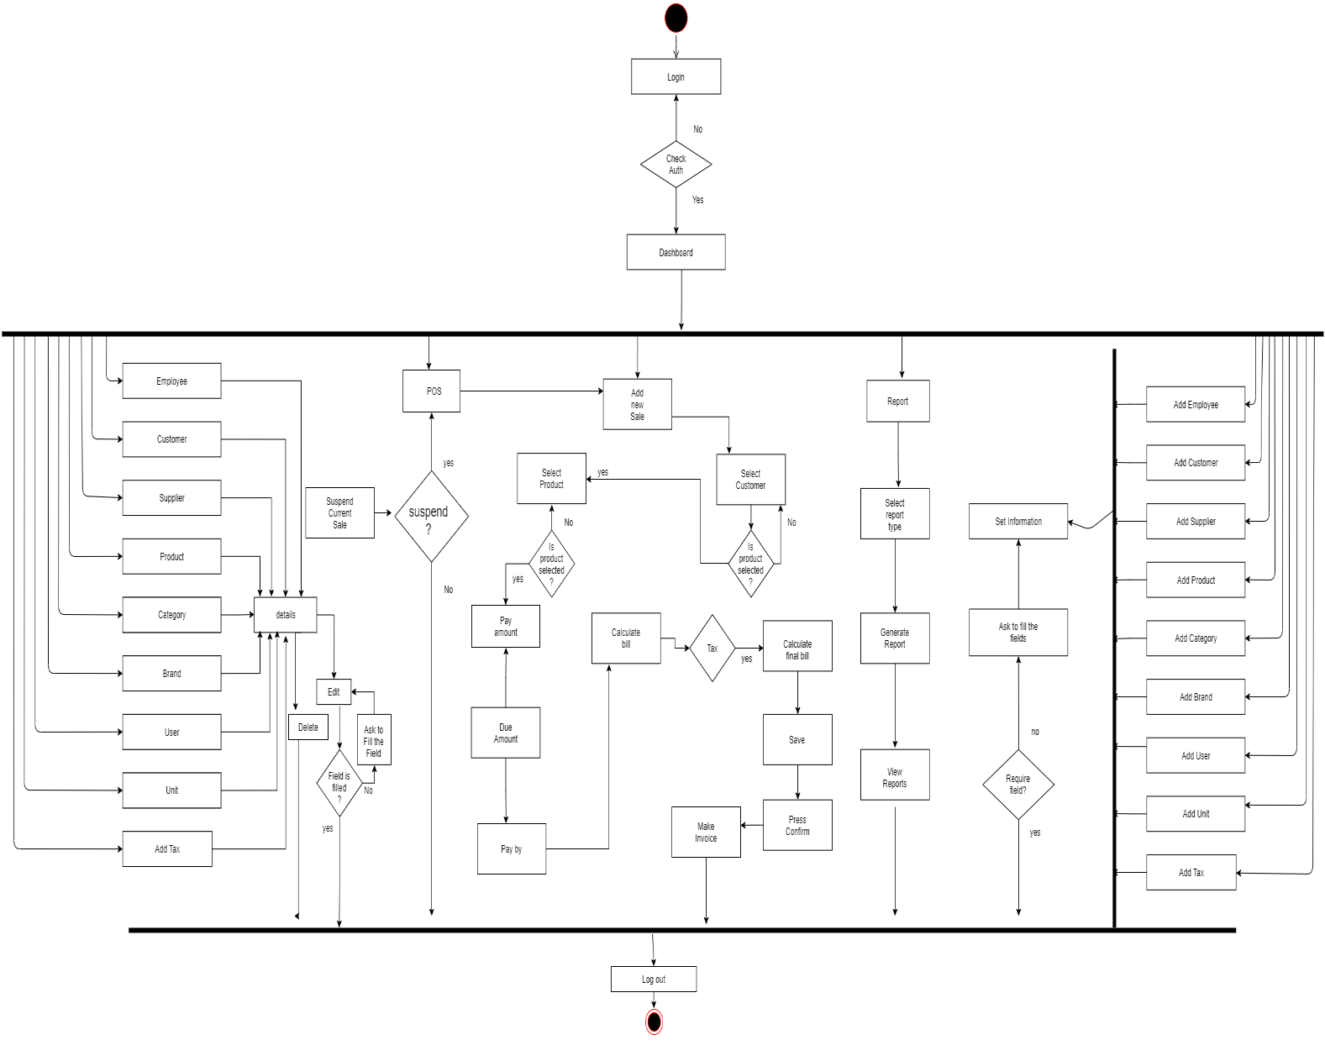

Figure 4: Activity Diagram for Admin.

Activity Diagram for Staff

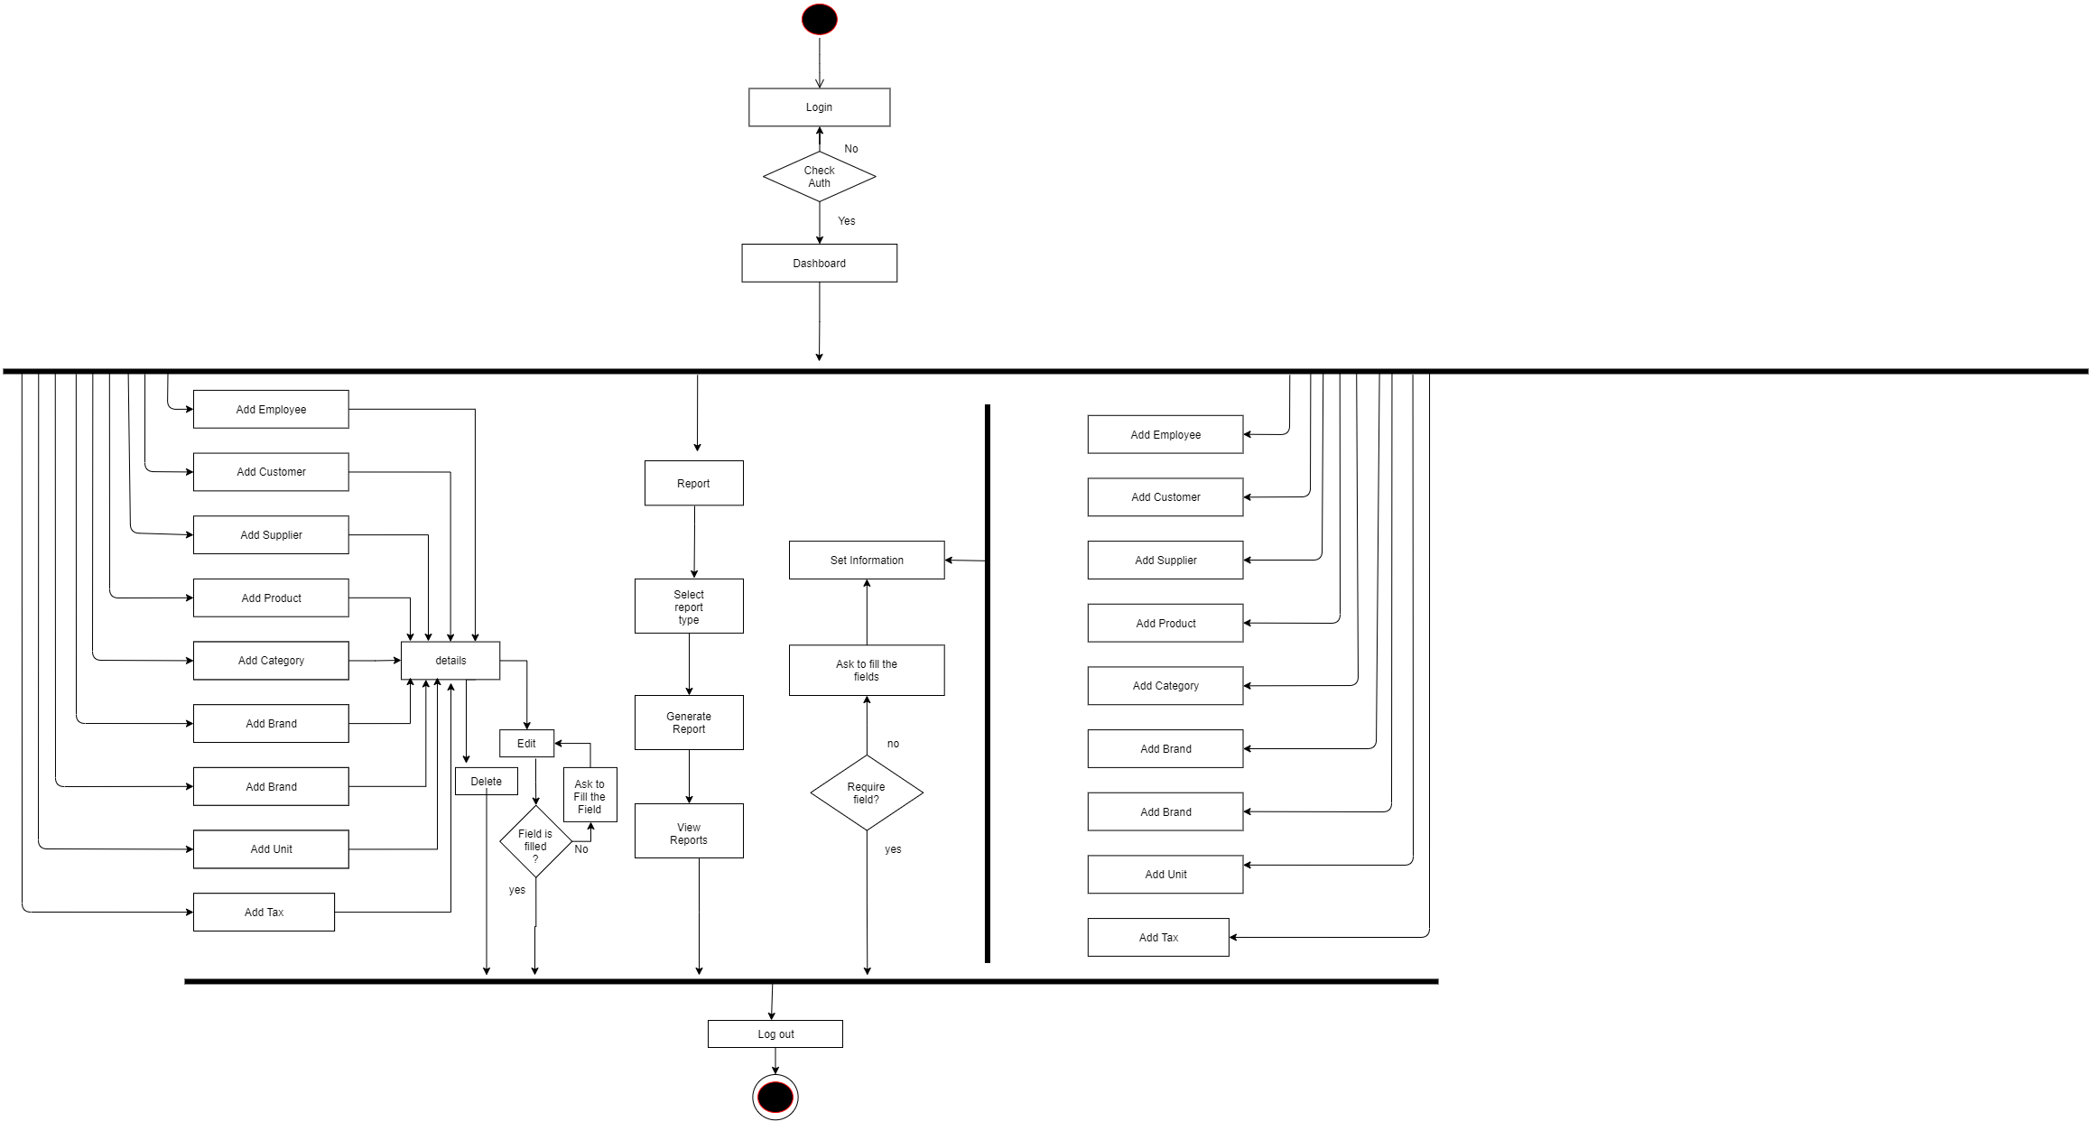
Figure 5: Activity Diagram for Staff.

Swim lane Diagram

A swim lane diagram is a type of flowchart that delineates who does what in a process. Using the metaphor of lanes in a pool, a swim lane diagram provides clarity and accountability by placing process steps within the horizontal or vertical “Swim lanes” of an employee, work group or department. It shows connections; communication and handoffs between these lanes, and it can serve to highlight waste, redundancy and inefficiency in a process.
Swim lane diagrams for the Point of Sale (POS) are given below:

Swim Lane Diagram for Owner

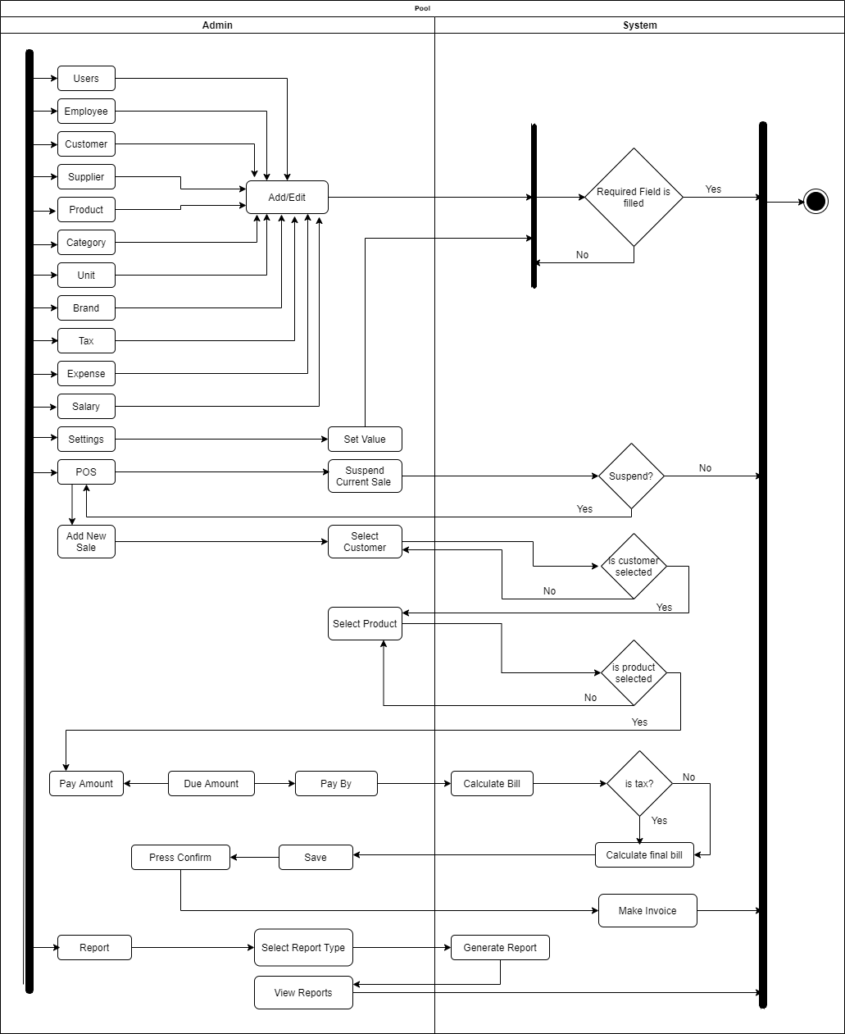

Figure 6: Swimlane Diagram for Admin.

Swim Lane Diagram for Owner

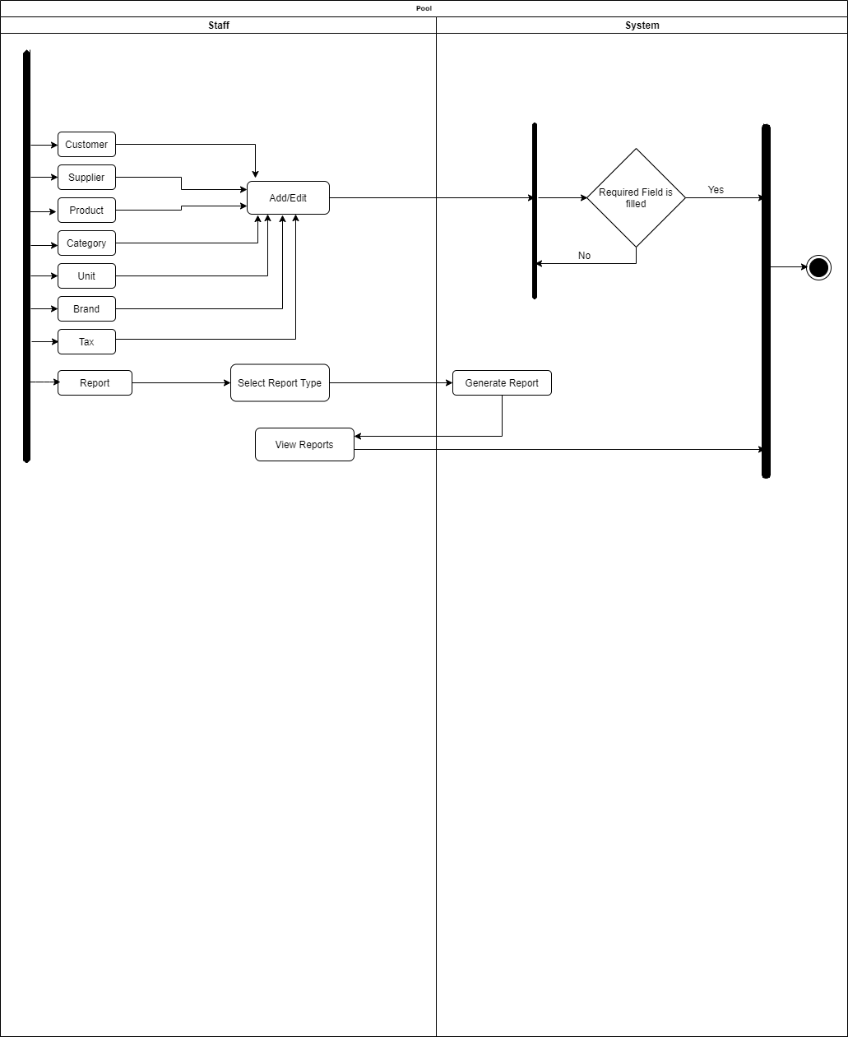

Figure 7: Swimlane Diagram for Staff.

Chapter 5: Risk Management

Risk Management

Risk analysis and management am a series of works that help a system development team to understand and manage uncertainty. Many problems can arise while developing a system. A risk is a potential problem – it may happen may not. There are several steps to analyze and manage risks. The first step is risk identification. Next each risk is analyzed to determine the likelihood that it will occur and the damage that it will do if it does occur. Once this information is established risks am remarked. Finally, a plan is developed to manage those risks with high probability and impact.

Risk Identification

Table II: Risk Identification
Risk type | Possible risks
Technology | - The database used in the system cannot process as many transactions per second as expected.  - Reusable software components contain defects that mean they cannot be reused as planned.
People | - It is impossible to recruit staff with the skills required.  - Key staff are ill and unavailable at critical times.  - Required training for staff is not available.
Organizational | - The organization is restructured so that different management are responsible for the project.  - Organizational financial problems force reductions in the project budget.
Tools | - The code generated by software code generation tools is inefficient.  - Software tools cannot work together in an integrated way.
Requirements | - Changes to requirements that require major design rework are proposed.  - Customers fail to understand the impact of requirements changes.
Estimation | - The time required to develop the software is underestimated.  - The rate of defect repair is underestimated.  - The size of the software is underestimated.

Risk Analysis

Risk analysis determines the potential impact of risk patterns or scenarios, the possible extent of loss, and the direct and indirect costs of recovery. This step identifies vulnerabilities, considers the willingness of the organization to accept risk given potential consequences, and develops mitigation responses
Table III: Risk Analysis
Risk | Probability | Effects
Organizational financial problems force reductions in the project budget. | Low | Catastrophic
It is impossible to recruit staff with the skills required for the project. | High | Catastrophic
Key staff are ill at critical times in the project. | Moderate | Serious
Faults in reusable software components must be repaired before these components are reused. | Moderate | Serious
Changes to requirements that require major design rework are proposed. | Moderate | Serious
The organization is restructured so that different management are responsible for the project. | High | Serious
The database used in the system cannot process as many transactions per second as expected. | Moderate | Serious
The time required to develop the software is underestimated. | High | Serious
Software tools cannot be integrated. | High | Tolerable
Customers fail to understand the impact of requirements changes. | Moderate | Tolerable
Required training for staff is not available. | Moderate | Tolerable
The rate of defect repair is underestimated. | Moderate | Tolerable
The size of the software is underestimated. | High | Tolerable
Code generated by code generation tools is inefficient. | Moderate | Insignificant

Risk Planning
Table IV: Risk Planning
Risk | Strategy
Organizational financial problems | Prepare a briefing document for senior management showing how the project is making a very important contribution to the goals of the business and presenting reasons why cuts to the project budget would not be cost effective.
Recruitment problems | Alert customers to potential difficulties and the possibility of delays; investigate buying-in components.
Staff illness | Reorganize team so that there are more overlap of work and people therefore understand each other’s jobs.
Defective components | Replace potentially defective components with bought-in components of known reliability.
Requirements changes | Derive traceability information to access requirements changes impact; maximize information hiding in the design.
Organizational restructuring | Prepare a briefing document for senior management showing how the project is making a very important contribution to the goals of the business.
Database performance | Investigate the possibility of buying a higher-performance database.
Underestimated development time | Investigate buying-in components; investigate use of program generator.

Risk Monitoring

    - Assess each identified risk regularly to decide whether it is becoming less or more probable.
    - Also assess whether the effects of the risk have changed.

Chapter 6: Project planning and scheduling

Functions of Proposed System

1. Today’s sales | [F01]
2. Point of sale management | [F02]
3. Add products in cart | [F03]
4. Rewrite products in cart | [F04]
5. Create payment | [F05]
6. Make sale | [F06]
7. Make Invoice | [F07]
8. Product management | [F08]
9. Expenses management | [F09]
10. Purchase management | [F10]
11. Category management | [F11]
12. Customer management | [F12]
13. User management | [F13]
14. Vendors management | [F14]
15. Due management | [F15]
16. Sales report | [F16]
17. Store settings | [F17]
18. Reports | [F18]

Function Specification

Function description descriptive the function in details. It concerns on three factors: what is the possible input, possible output for a function and which table of the database uses by that function.
Table V: Function Specification
Functionality | Input | Output
Admin can view today’s sales details | Click on the sale reports from top bar dropdown | View todays sales, revenue, due, purchase, expense as default
Admin can view all category and add, edit, search and delete category | Click on the add/update/delete button, fill up all required fields | Add, modify and delete category
Admin can view product list and add, edit, search and delete products | Click on the add/update/delete button, fill up all required fields | Add, modify and delete products
Admin and Staff can view expense and add, edit, search and delete expense | Click on the add/update/delete button, fill up all required fields | Add, modify and delete Expense
Admin can add, edit, search and delete purchases and vendor | Click on the add/update/delete button, fill up all required fields | Add, modify and delete purchases and vendor
Admin can view, add, edit or delete customers | Click on the add/update/delete button, fill up all required fields | Add, modify and delete customers
Admin can add, edit, search and delete vendor | Click on the add/update/delete button, fill up all required fields | Add, modify and delete vendor
Admin can see all types of report | Select types of report | See report
Admin can set store setting (Image, name etc) | Click on setting from sidebar | Modify store setting
Admin add, edit, search and delete user/employees | Click on the add/update/delete button, fill up all required fields | Add, modify and delete users
Admin and Staff can make sale and create invoice | Select items, create bill, receive payment, cancel order | Make invoice
Staff can see details of products, categories | Click on products/ categories | See details

  - Function Point Estimation
Table VI: Transaction function
Transaction function | Fields/File involvement | FTR | DET
Manage category (2*EI) | Fields - Code, image, details Files - categories | 1 | 3
Manage products (2*EI) | Fields – code, name, image, quantity, category, type, cost, price  Files – category, products | 2 | 8
Manage expenses (2*EI) | Fields – date, reference, amount, note Files- expenses | 1 | 4
Manage purchases (2*EO) | Fields – date, reference, products, total, totalAmount, vendor, received  Files – purchase, products, vendor | 3 | 7
Manage Customer (2*EI) | Fields – name, email, contact, address Files - customers | 1 | 4
Manage vendor (2*EI) | Fields – name, email, contact, address Files - vendors | 1 | 4
Manage users (2*EI) | Fields – name, email, password, type Files - users | 1 | 4

Make sales (EO) | Fields – customerID, paymentStatus, reference, saleNote, total, orderedDiscount, grandtotal, item, itemType, staffNote, saleID, saleDate, productID, quantity, cost, salePrice, subtotal, discount, saleID, customerID, addedDate, amount, due, note  Files – sales, saleitems, products, payments, customers | 5 | 24
Repay due (EO) | Fields – saleID, customerID, amount, due, status Files – payment, sales | 2 | 5
See sales  /customer report (EQ) | Fields – date, sales, purchase, expense, due, productName, customerName, quantity, revenue, paymentStatus, discount Files – sales, saleitems, payments, products, purchase, expenses, customers | 7 | 11
Manage store setting (EQ) | Fields – name, address, image, favicon Files – setting | 1 | 4
Manage theme (EQ) | Fields – customerID, name, contact, email, password, sidebar, topbar, brandName, footer, borderedLine  Files – theme, customers | 2 | 10

Table VII: Data Functions
Data functions | Fields/ File involvement | RETs | DETs
Add to cart (ILF) | Fields- productName, price, quantity, subtotal, discount, saleNote | 3 | 6
Calculate Grantotal (ILF) | Fields – salePrice, subtotal, discount | 2 | 3

Table VIII: Unadjusted Function Point Contribution (Transition Function)
Transaction function | FTR | DET | Complexity | UFP
Manage category (2*EI) | 1 | 3 | 2*Low | 6
Manage products (2*EI) | 2 | 8 | 2*Average | 8
Manage expenses (2*EI) | 1 | 4 | 2*Low | 6
Manage purchases (2*EO) | 3 | 7 | 2*Average | 10
Manage Customer (2*EI) | 1 | 4 | 2*Low | 6
Manage vendor (2*EI) | 1 | 4 | 2*Low | 6
Manage users (2*EI) | 1 | 4 | 2*Low | 6
Make sales (EO) | 5 | 24 | High | 7
Repay due (EO) | 2 | 5 | Low | 4
See sales /customer report (EQ) | 7 | 11 | High | 6
Manage store setting (EQ) | 1 | 4 | Low | 3
Manage theme (EQ) | 2 | 10 | Average | 4
Total |  |  |  | 72

Table IX: Unadjusted Function Point Contribution (Data Function)
Data functions | RETs | DETs | Complexity | UFP
Add to cart (ILF) | 3 | 6 | Average | 10
Calculate Grantotal (ILF) | 2 | 3 | Low | 7
Total |  |  |  | 17

Table X: Performance and Environment Impact
General System Characteristics | Brief Description | DI
Data communications | How many communication facilities are there to aid in the transfer or exchange of information with the application or system? | 3
Distributed data processing | How are distributed data and processing functions handled? | 0
Performance | Was response time or throughput required by the user? | 3
Heavily used configuration | How heavily used is the current hardware platform where the application will be executed? | 1
Transaction rate | How frequently are transactions executed daily, weekly, monthly, etc.? | 4
On-Line data entry | What percentage of the information is entered On-Line? | 5
End-user efficiency | Was the application designed for end-user efficiency? | 4
On-Line update | How many ILF’s are updated by On-Line transaction? | 2
Complex processing | Does the application have extensive logical or mathematical processing? | 3
Reusability | Was the application developed to meet one or many user’s needs? | 2
Installation ease | How difficult is conversion and installation? | 1
Operational ease | How effective and/or automated are start-up, back-up, and recovery procedures? | 1
Multiple sites | Was the application specifically designed, developed, and supported to be installed at multiple sites for multiple organizations? | 3
Facilitate change | Was the application specifically designed, developed, and supported to facilitate change? | 0
Total degree of influence (TDI) |  | 32

▸ Value adjustment factor (VAF)= (.65+(.01*TDI)
= (.65+(0.01*32)
= 0.97

▸ Unadjusted Function point count (UFP) = UFP (Data function) + UFP (Transaction Function)
= 17+72
= 89

▸ Adjusted Function point count (AFP) = UFP * VAF
= 89 * 0.97
= 86.33
Table XI: Function Point Estimation

Value adjustment factor  (VAF) | 0.97
Unadjusted Function point count (UFP) | 89
Adjusted Function point  count (AFP) | 86.33
Effect for codeIgniter | AFP * Productivity for Php
Effect for codeIgniter | 86.33 * 15.5 | Productivity for Php = 15.5
Effect for codeIgniter | 1338.115 | Person Hours
Effect for codeIgniter | 167.26 | Person Days (8 Hours Per Day)
Effect for codeIgniter | 7.27 | Person Months (23 Days Per Month)
Effect for codeIgniter | 3.64 | Months (2 person for developing the project)

Process Based Estimation

In process-based estimation, process is decomposed into a relatively small set of tasks and the effort required to accomplish each task is estimated. Process based estimation begins with a delineation of software functions obtained from the project scope. A series of software process activities must be performed for each function.

Table XII: Process Based Estimation
Function | Pre- requisite |  | Engineering |  | Construction & release |  | CE | Total
Function | CC | Planning | Analysis | Design | Code | Test | CE | Total
F01 | 0.3 | 0.1 | 0.3 | 1.5 | 2 | 1 | N/A | 5%
F02 | 0.2 | 0.3 | 1.5 | 2 | 2 | 2 | N/A | 8%
F03 | 0.1 | 0.15 | 0.55 | 0.55 | 5 | 0.75 | N/A | 7%
F04 | 0.2 | 0.4 | 2 | 2 | 4 | 2 | N/A | 11%
F05 | 0.01 | 0.15 | 2 | 2 | 3 | 2 | N/A | 9%
F06 | 0.01 | 0.15 | 0.6 | 0.6 | 2 | 0.8 | N/A | 4%
F07 | 0.15 | 0.14 | 0.5 | 0.5 | 1 | 0.6 | N/A | 3%
F08 | 0.15 | 0.2 | 0.8 | 0.8 | 2 | 0.6 | N/A | 5%
F09 | 0.1 | 0.15 | 0.8 | 0.7 | 1 | 0.5 | N/A | 3%
F10 | 0.2 | 0.25 | 0.9 | 0.9 | 2 | 0.7 | N/A | 5%
F11 | 0.15 | 0.15 | 0.8 | 0.9 | 1 | 0.9 | N/A | 4%
F12 | 0.1 | 0.15 | 0.8 | 0.9 | 4 | 1 | N/A | 7%
F13 | 0.02 | 0.02 | 0.8 | 0.7 | 3 | 1 | N/A | 6%
F14 | 0.02 | 0.03 | 1.5 | 1 | 2 | 0.8 | N/A | 5%
F15 | 0.15 | 0.2 | 0.6 | 0.8 | 2 | 1 | N/A | 5%
F16 | 0.15 | 0.2 | 0.4 | 0.7 | 2 | 1 | N/A | 4%
F17 | 0.02 | 0.03 | 0.4 | 0.5 | 1 | 1 | N/A | 3%
F18 | 0.02 | 0.03 | 0.3 | 0.4 | 3 | 2 | N/A | 6%
Total | 2% | 3% | 16% | 17% | 42% | 20% | 0% | 100%

Effort Distribution

The project estimation technique leads to estimates of work units required to complete the software development. A recommended distribution of effort across the definition and development phases referred as the 40-20-40 rule. Forty percent of all effort allocated to frontend analysis and design, twenty percent allocated to coding and the remaining forty percent allocated to back-end testing. This rule used as a guideline only.
In this project, 38% of full software development has been allocated to communication, Planning, analysis and design, 42% has allocated to coding and the remaining 20% is allocated to software testing and support.




Figure 8: Effort Based Estimation
Effort Distribution
2%

3%
20%
16%
17%
CC
Planning Analysis Design Coding
Testing
42%

Project Schedule

Total system development is a combination of set of tasks. These set of tasks should do sequentially and timely. Project schedule works as the guideline of the system developer. The following is the schedule chart of this project:
Events | W1 |  |  | W2 | W3 |  | W4 | W5 |  | W6 | W7 | W8 | W9 | W10 | W11
CC
Planning
Analysis
Designing
Coding
Testing

Figure 9: Project Scheduling Chart

Chapter 7: Project Estimation

Project Estimation

The accuracy of a software project estimate predicated based on a number of things:
    - Properly estimated the size of the product to build.
    - The ability to translate the size estimation into human effort, calendar time and money.
    - The degree to which the project plan reflects the abilities of the software team or engineer.
    - The stability of the product requirements and the environment that supports the software engineering effort.
Software size estimation is the most important matter that I have to consider during the software project. If the software size not calculate properly, then this will cause various problems such as scheduling problems, budget problem etc. As the project goes on before estimating the software size, I have to confirm that software scope is bounded.

Personal cost

Number of days in a year = 365
Number of government holidays in a year =24 Number of weekly holidays in a year =52
Total number of working days to develop the project =365-(52+24) =289 days
Total number of working days per month to develop the project =289/12 =24.083 days Organization working hours per day = 8 hours
Organization working hours per month=24.083*8= 192.66 hours

Table XIII: Salary range
Position | Salary/Month | Salary/Hour
System Analyst, Project Manager | 25,000 | 129.76
System designer, Coder, Tester | 15,000 | 77.86

  - Hardware cost
Table XIV: Hardware Cost
Particulars | Quantity | Depreciation calculation | Depreciation Expense
Computer | 1 | 93,000*4.16 | 3875
Printer | 1 | 8,000*25.00% | 2000

Software cost
Table XV: Software cost
Particulars | Cost
Vs Code | Free
Chrome Browser | Free
Xampp | Free

Other Cost
Table XVI: Other Cost
Particulars | Cost
Furniture | 500
Electricity bill | 200
Extra | 800

Accounts table
Table XVII: Accounts Table
Particulars | Cost | Cost
Salary-
- System Analyst, | 129.76*8*30 | 31142.7
Project Manager
- System designer, | 77.86*8*65 | 40487.2
Coder, Tester
 |  | Total- 71629.6
Hardware cost
- Computer | 3875 | 3875
- Printer | 2000 | 2000
 |  | Total- 5875
Software cost-
Vs code  FireFox Browser  Xampp | Free Free Free
 |  | Total-0
Other cost-
- Furniture | 500 | 500
- Electricity bill | 200 | 200
- Extra | 1200 | 1200
 |  | Total- 1500
Total |  | 79004.6

Chapter 8: Quality Management

The system quality management and the planning for the software quality management of the project ‘Point of Sale’ is given in the chapter quality management.

System Quality Management

Software quality management for the project ‘Point of Sale’ ensures that the required level of quality is achieved by submitting improvements to the product development process. The quality of this software is measured, and the process is improved until the proper quality level is achieved. It is measured by a number of variables. The aim of this software quality management is to manage the quality of this ‘Point of Sale’ software and of its development process

Software Quality Management Processes

Software quality management of the project ‘Point of Sale’ involves the application of specific quality processes and checking that these planned processes have been followed. The processes involved in the software quality management of this software. They are:

Quality Planning

Quality planning is performed by first selecting the applicable procedures and standards for this project ‘Point of Sale’ and then modifying these as required. All the important factors that contribute the customer requirements are explained in this development.

Quality Assurance

Quality assurance established organizational procedures and standards for the quality of the project ‘Point of Sale’. It involved evaluating overall project performance to ensure that the project can fulfill the relevant quality standards.

Quality Control

Quality control for the project ‘Point of Sale’ ensured that the software development team implemented procedures and standards. Project result is monitored to ensure that improve while identifying ways the overall quality according to quality standards.

Chapter 9: Designing

Data Flow Diagram

A data flow diagram (DFD) is a graphical representation of the “flow” of data through an information system, modeling its process aspects. A DFD is often used as a preliminary step to create an overview of the system, which can later be elaborated DFDs can also, be used for the visualization of data processing.
A DFD shows what kind of information will be input to and output from the system, where the data will come from and go to, and where the data will be stored. It does not show information about the timing of process or information about whether processes will operate in sequence or in parallel.

Context Level DFD
The context level data flow diagram for “Point of Sale” is given below:

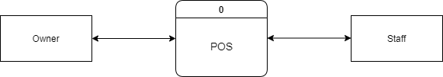
Figure 10: Context level Data Flow Diagram

Owner and Staff are the external entities of the system. There are several data flow from all the entities. The figure shows the data flow from external entities towards the system and from the system towards the external entities.

Level 1 DFD

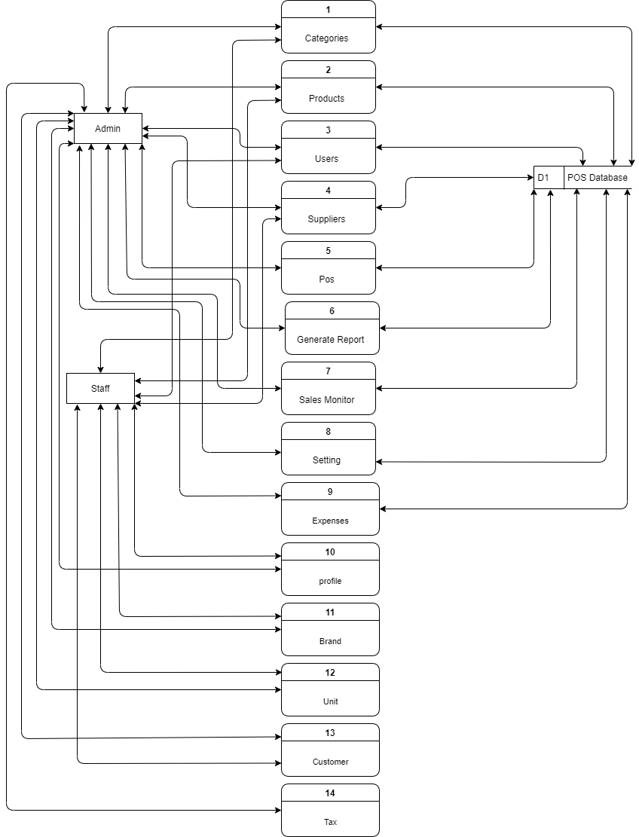

Figure 11: Level 1 data flow diagram

Level 2 Process 1

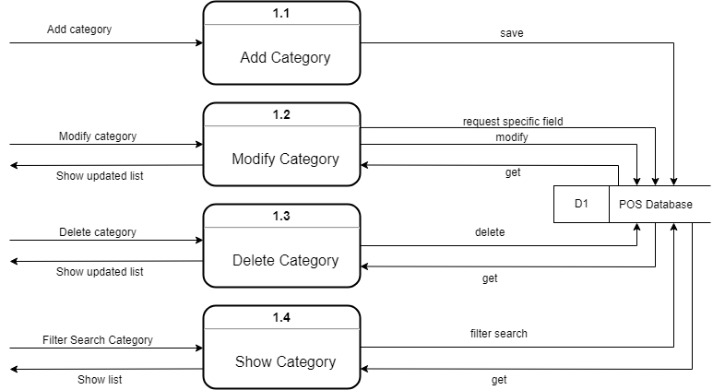
Figure 12: Level 2 Process 1

Level 2 Process 2

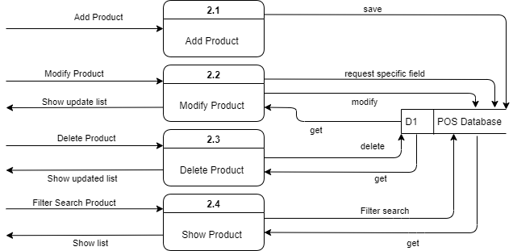
Figure 13: Level 2 Process 2

Level 2 Process 3

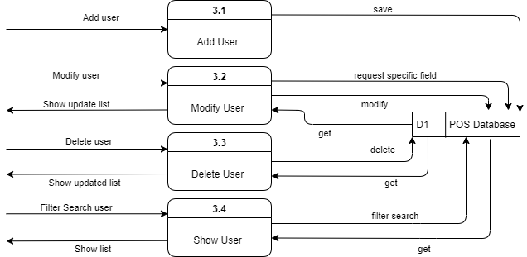
Figure 14: Level 2 Process 3

Level 2 Process 4
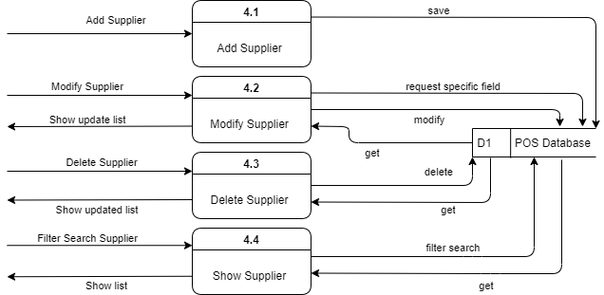

Figure 15: Level 2 Process 4

Level 2 Process 5

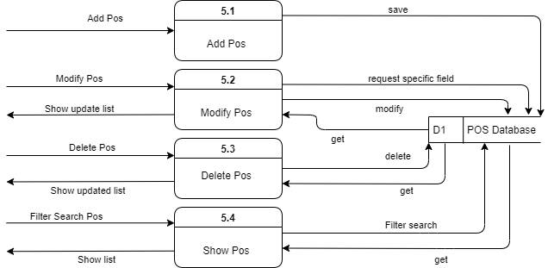
Figure 16: Level 2 Process 5

Level 2 Process 6

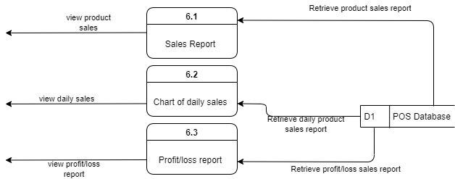
Figure 17: Level 2 Process 6

Level 2 Process 7

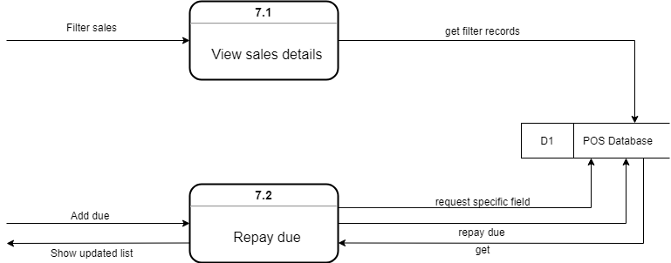
Figure 18: Level 2 Process 7

Level 2 Process 8

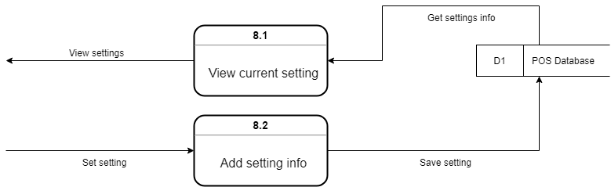
Figure 19: Level 2 Process 8

Level 2 Process 9

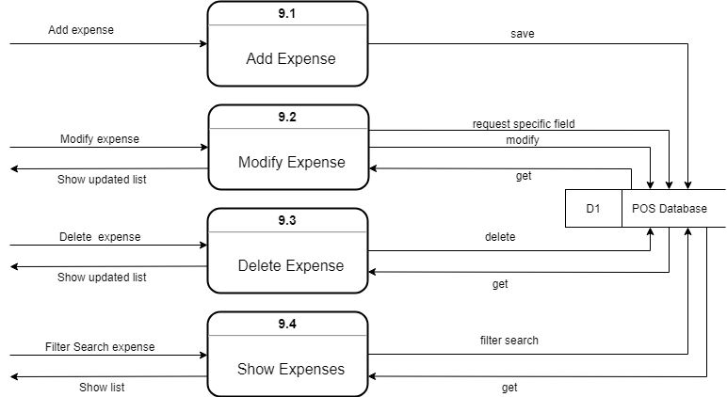
Figure 20: Level 2 Process 9

Level 2 Process 10

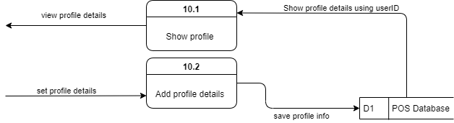
Figure 21: Level 2 Process 10

Level 2 Process 11

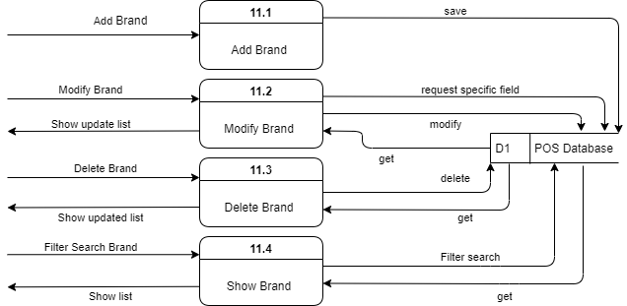
Figure 22: Level 2 Process 11

Level 2 Process 12

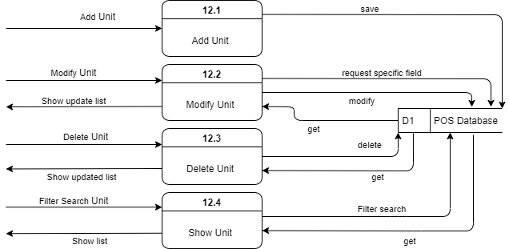
Figure 23: Level 2 Process 12

Level 2 Process 13

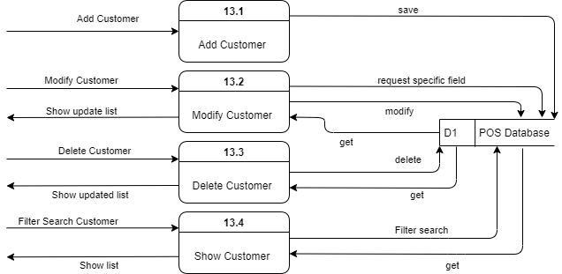
Figure 24: Level 2 Process 13

Level 2 Process 14

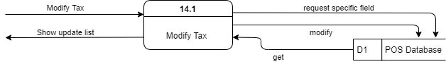
Figure 25: Level 2 Process 14

Database Design

Database design is the organization of data according to a database model. The designer determines what data must be stored and how the data elements interrelate. With this information, they can begin to fit the data to the database model.
In this section database design of the Point of sale (POS) is given below:

Entity Relationship Diagram
An entity-relationship diagram (ERD) is a data modeling technique that graphically illustrates an information system's entities and the relationships between those entities. An ERD is a conceptual and representational model of data used to represent the entity framework infrastructure.

An ER Diagram contains three properties
▸ Entities: Entity is a definable thing or concept within a system
▸ Attributes: An attribute is a property or characteristic of the entity that holds it
▸ Relationships: A relationship between two entities signifies that the two entities are associated with each other somehow.

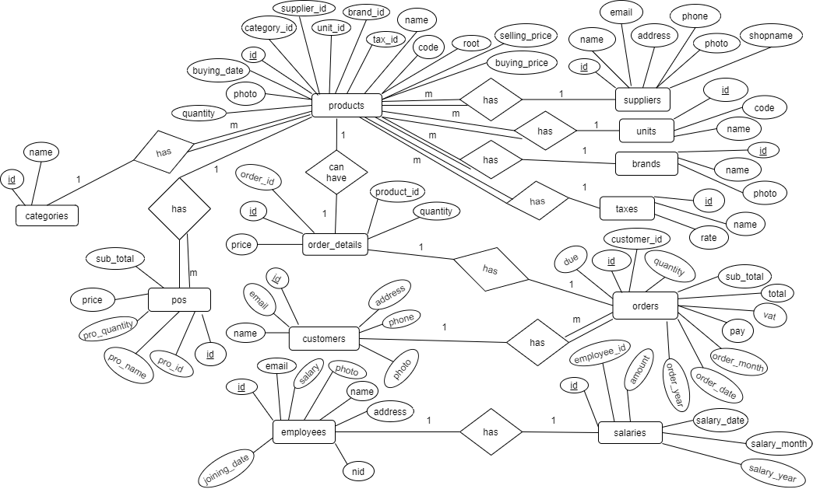

Figure 26: Entity Relationship Diagram

    - Normalization

1st normal form:

Step# 1: Database is normalized for this step

Step# 2: Find primary key
- Categories id
- Customers id
- Expenses id
- Payments id
- Products id
- Purchases id
- Saleitems id
- Sales id
- Setting id
- Theme id
- Users id
- Suppliers id

Step# 3: Find out the dependencis

1: Partial key dependency
▸ CategoriesID – image, code, name, addedBy, addedTime, deleted
▸ CustomersID - name, email, contact, address, addedBy, addedTime, deleted
▸ ExpensesID - date, reference, amount, note, addedBy, addedTime, deleted
▸ PaymentsID – sale, customer, addedDate, amount, due, note, adBy, deleted
▸ ProductsID - image, code, name, type, category, quantity, cost, price, addedBy, addedTime, deleted
▸ PurchasesID - date, reference, product, total, totalAmount, vendor, received, addedBy, addedTime, deleted
▸ SaleitemsID – saleID, saleDate, productID, qty, cost, orgSubTotal, salePrice, subTotal, discount, addBy, deleted
▸ SalesID – date, customerID, paymentStatus, reference, saleNote, total, orderedDiscount, grandTotal, orgCostTotal, item, itemType, staffNote, addedBy, deleted
▸ SettingID –image, favicon, name, address, updateBy, addedTime, deleted
▸ ThemeID – userID, topBar, sideBar, centerBrand, colorBrand, borderMenu, flippedSideBar, footerOption
▸ UsersID – image, name, email, password, type, ip, addedBy, addedTime, deleted
▸ VendorsID - companyName, name, email, contact, address, addedBy, addedTime, deleted

Database Field Design

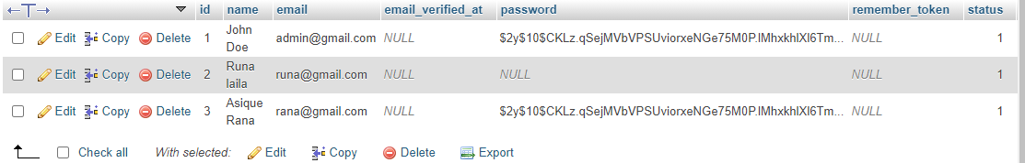

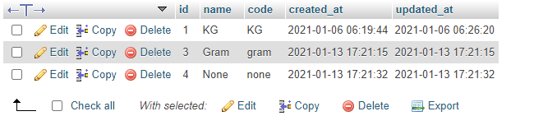

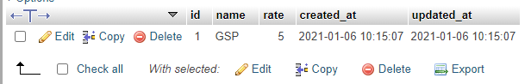

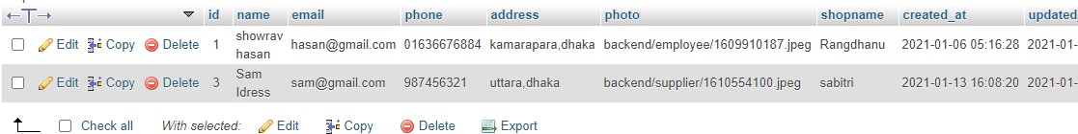

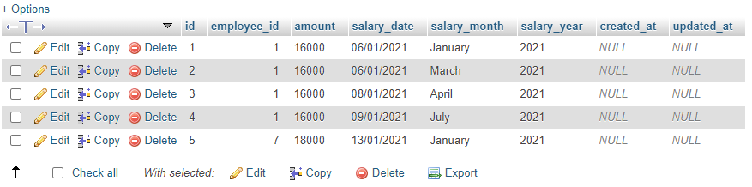

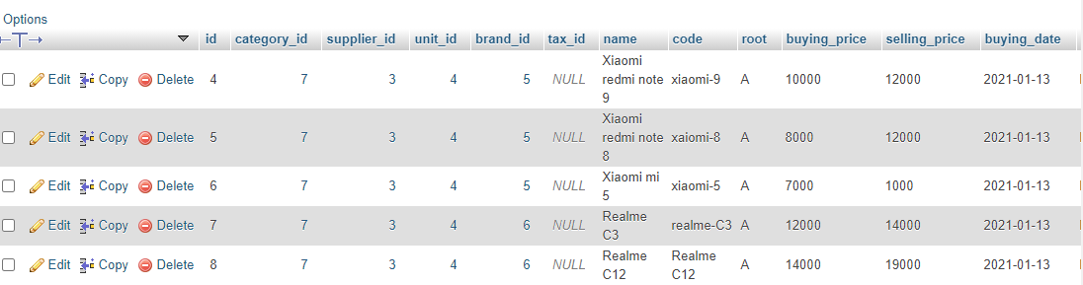

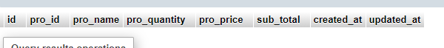

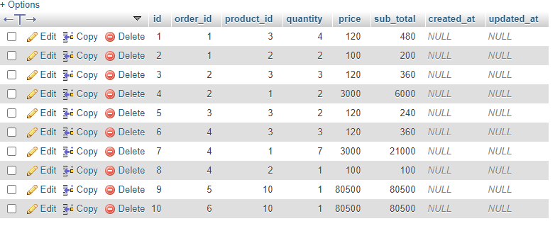

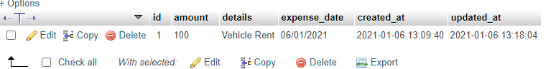

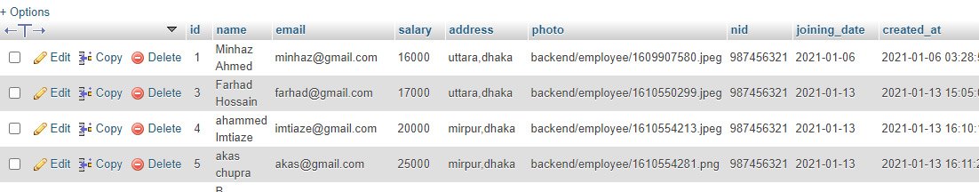

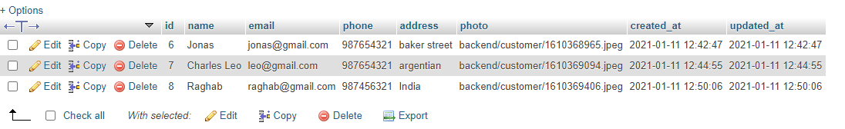

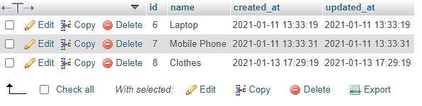

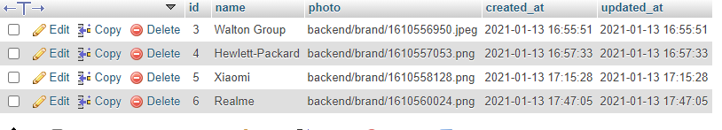

Chapter 10: Testing

Software Testing Strategy

A strategy for software testing integrates software test case design methods into a well- planned series of steps that result in the successful construction of a software. The strategy provides a road map that describes the steps to be conducted as part of testing.

Testing strategy that will be followed in this software project –
    - Unit testing
    - Integration testing
    - Validation testing

The first step in software testing is unit testing. Unit testing concentrates on each unit of the software as implemented in source code. Unit testing focuses on each component individually. The unit test is white-box oriented. Thus, unit testing of this library software will be done after completion of every module or component.
The next step is integration testing. Integration testing is a systematic technique for constructing the program structure while at the same time conducting tests to uncover errors associated with interfacing. The objective of integration testing is to take unit tested components and build a program structure that has been dictated by design.
The integration testing strategy that has been chosen for this project is top down testing. Black- box testing method is the most prevalent for integration testing. Top down integration strategy will be used to perform integration testing. Top down integration will be done by breadth-first manner. Breadth-first integration incorporates all components directly subordinate at each level, moving across the structure horizontally.
After the software has been integrated, a set of high order tests am conducted. Hence, the validation criteria that have been mentioned in requirements engineering should be tested. Validation testing provides final assurance that software meets all functional, behavioral and performance requirements. The black-box testing method is exclusively used in validation.

System Testing Methodology

Black-box Testing
Black-box testing which is also known as behavioral testing focuses on the functional requirements of the software. It enables the software engineer to derive sets of input conditions that will fully exercise all functional requirements for a program. Black-box testing method will be applied to test the modules of LMS.
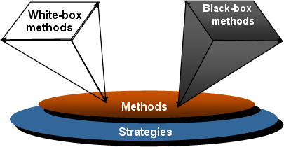

White-box Testing
White-box testing, which also known as glass-box testing, is a test case design method that uses the control structure of the procedural design to derive test cases. Using white-box testing methods, software engineer can derive test cases that,
- Guarantee that all independent paths within a module have been exercised at least once
- Exercise all logical decisions on their true and false sides
- Execute all loops at their boundaries and within their operational bounds
- Exercise internal data structures to ensure their validity.

The modules that contain some complex calculations or decision-making code such as check the availability of the library item will be tested using white-box method.

Testing

Input’s | No user inputs
Desired output | View todays sale, due, revenue, purchase, expense and products / customers individual report
Actual output | Successfully showed those items
Verdict | Getting all the desired output from the system.

Input’s | Customer data and items with quantity
Desired output | Can select product and customer to create invoice for customer also can suspend order and edit item from cart.
Actual output | All the functions are working well
Verdict | Getting all the desired output from the system.

Input’s | Add new expenses with references and net amount
Desired output | Can add, delete and view expenses
Actual output | All the functions are working well
Verdict | Getting all the desired output from the system.

Input’s | Add new product with name, image, category, cost and price
Desired output | Can add, delete and view products
Actual output | All the functions are working well
Verdict | Getting all the desired output from the system.

Input’s | Add new category with category name and category image
Desired output | Can add, delete and view category
Actual output | All the functions are working well
Verdict | Getting all the desired output from the system.

Input’s | Search with keyword to find the specific record
Desired output | View all sale report and can be able to manage them
Actual output | All the functions are working well
Verdict | Getting all the desired output from the system.

Input’s | Add new customer with name, contact, image and address
Desired output | Can add, delete and view customers
Actual output | All the functions are working well
Verdict | Getting all the desired output from the system.

Input’s | Add new user with name, contact, image, type and address
Desired output | Can add, delete and view users
Actual output | All the functions are working well
Verdict | Getting all the desired output from the system.

Input’s | No input
Desired output | Can add, update due payment
Actual output | All the functions are working well
Verdict | Getting all the desired output from the system.

Input’s | No input
Desired output | Can see the product warehouse storage
Actual output | All the functions are working well
Verdict | Getting all the desired output from the system.

Input’s | No input
Desired output | Edit details of user and set theme from dropdown selection
Actual output | All the functions are working well
Verdict | Getting all the desired output from the system.

Input’s | No input
Desired output | Can edit store setting (name, address, and others)
Actual output | All the functions are working well
Verdict | Getting all the desired output from the system.

Input’s | Make pos order
Desired output | Can see list products and their sale price, subtotal, grand total, due/change
Actual output | All the functions are working well
Verdict | Getting all the desired output from the system.

Input’s | No input
Desired output | Can view all kinds of report like profit loss report, daily sales report, chart report and date range report
Actual output | All the functions are working well
Verdict | Getting all the desired output from the system.

Chapter 11: Conclusion

Practicum and Its Value

Practicum is the transition from engineering college study life to a real-world workplace through hands on experience of engineering practices. It helps to develop of deeper skills in the selected research area and increases employability. Meeting with different types of people and encountering situations gives practical orientation to life. There are many more upright issues of practicum, which only the person experiencing it can sense and believe. Student of College of Engineering and Technology (CEAT) at IUBAT go for this practicum program carrying 6 credit hours weight, which goes for a semester long and usually after the completion of the course work.

Future Plan

    - Add more payment system
    - Add Barcode Scanner
    - Make a website to show report from any where

Conclusion

The biggest experience working at GENIUS OCEAN is indeed being a part of designing and implementing software. Our most experience was round the designing issue. We have learnt a lot of new things which was unknown to us. We have also learnt some technical issues which help to do better in future life. The following indicator will indicate some of our technical issue which we have learnt and implemented from this project.

▸ The designing strategy of a PHP based project.
▸ The analyzing strategy of a project.
▸ Developing a project that can be accessed over internet.
▸ Real life experience with MYSQL and PHP (Laravel).

Appendix

Actor: An actor is a user of the system playing a particular role
AFP: Adjusted Function Point
Attribute- Attributes are the particular properties which are used to describe the entity.
BCSE- Bachelor of Computer Science and Engineering
CC- Customer Communicator
CEAT: College of Engineering and Technology

EIF- External Interface File
Entity- An entity is something that exists as itself, as a subject or as an object, actually or potentially, concretely or abstractly, physically or not. It need not be of material existence. In particular, abstractions and legal fictions are usually regarded as entities
EO- External Output
EQ- External Query
ERD - Entity Relationship Diagram, An Entity Relationship Diagram is a snapshot of data structures
Estimation- A project planning activity that attempts to project effort and cost for the project
FK- Foreign Key, A foreign key is a column or group of columns in a relational database table that provides a link between data in two tables
FP- Function Pint, a measure of the utility delivered by an application
FTR- File Type Referenced
GSC- General System Characteristics
ILF- Internal Logical File
IUBAT- International University of Business Agriculture and Technology
MS- Microsoft
Normalization- Normalization is a step by step decomposition of complex database into a simple one
PK- Primary Key, A primary key is a special relational database table column (or combination of columns) designated to uniquely identify all table records

Project Scheduling- project scheduling is an activity of distributing the estimated efforts within the planned project duration
POS: Point of Sale
QA: Quality Assurance
QMS: Quality Management System
RET- Record Element Type
SQL- Structured Query Language/ Standardized Query Language
SQM: System Quality Management
TDI- Total Degree of Influence
TQM: Total Quality Management
UFP- Unadjusted Function Point
VAF- Value Adjustment Factor

References

Books:
- Kendall, E. & Kendall (1999), System Analysis and Design. 4th Ed. New Delhi: Prentice Hall.
- Pressman, Roger S. (2004). Software Engineering: A Practitioner’s Approach. 5th ed. Boston: McGraw Hill.
- Silberschattz, Abraham, Korth, Henry F., & Sudrashan S. (2002). Database System Concepts. 4th ed. Boston: McGraw Hill.

Websites:
- How to calculate function points. (2018, Aug 03). Available at: http://stackoverflow.com/questions/34473698/how-to-calculate-function-points
- Longstreet, David. (2005). Fundamentals of Function Point Analysis. [Online] Available at: http://www.softwaremetrics.com/fpafund.htm
- Mamčenko. J, Introduction to Dta Modeling and MSAccess. (2018, Aug 07). Available at: http://gama.vtu.lt/biblioteka/Information_Resources/i_part_of_information_resources. pdf
- Organizational System Approach: Continuous Software Development Excellence Process. [Online] Available at: ixorasolution.com/process
- Shingote, S. Explain incremental Process Model with example. (2018, Aug 09). Available at: http://www.ques10.com/p/21784/explain-incremental-process-modelwith-example/
- Tutorials Point. (2015). Database Management System. (2018, June 30). Available at: https://www.tutorialspoint.com/dbms/dbms_tutorial.pdf
- ERD. Available at: https://www.visual-paradigm.com/guide/data-modeling/what-isentity-relationship-diagram/

Work Cited:

draw.io (for designing the diagrams), MS word 2019, MS excel 2019

